IT13: ADBMS
Chapter 2:SQL
Practice Assignment Solution Template

Write a query and paste a screenshot of your output below the question.
- Create a database named CompanyDB.
CREATE DATABASE COMPANY_DB
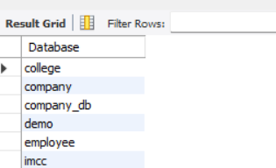
- Create a table Employees with the following columns:em
Employees (EmpID (Integer, Primary Key), EmpName, Salary, JoinDate )

CREATE TABLE employees (
empid INTEGER PRIMARY KEY,
empname VARCHAR(20),
salary INT,
joindate DATE
);

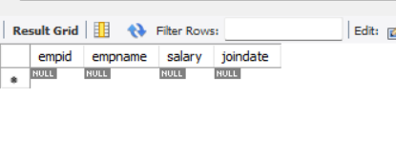
- Create a table Departments with:
Departments (DeptID (Integer, Primary Key), DeptName)

CREATE TABLE DEPARTMENTS (
DEPTID INTEGER PRIMARY KEY,
DEPTNAME VARCHAR(20)
);
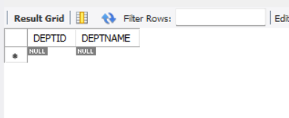
- Add a column Email (VARCHAR(100)) to the Employees table.
ALTER TABLE EMPLOYEES ADD( EMAIL VARCHAR(100));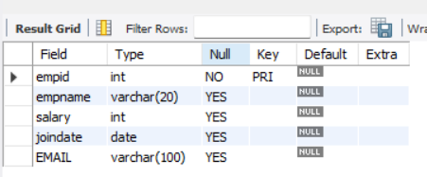
- Add a column dept_location to the Departments table.
ALTER TABLE DEPARTMENTS ADD(DEPT_LOCATION varchar(20));
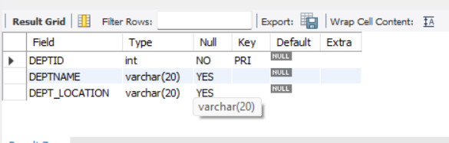
- Add a NOT NULL Constraint to the Phone column
ALTER TABLE EMPLOYEES ADD( PHONE INT NOT NULL);
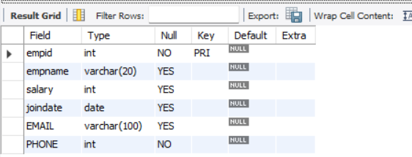
- Change the size of the EmpName column from VARCHAR (50) to VARCHAR (100).
ALTER TABLE EMPLOYEES MODIFY EMPNAME VARCHAR(100);
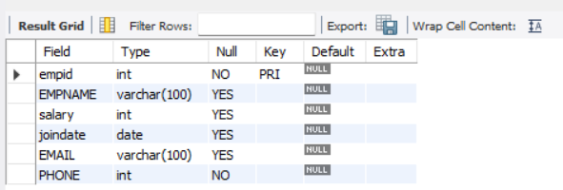
- Drop the primary key Constraint from Departments
ALTER TABLE DEPARTMENTS DROP PRIMARY KEY;
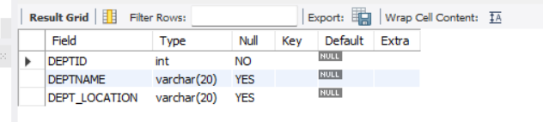
- Create a foreign key constraint between two tables
ALTER TABLE EMPLOYEES
ADD CONSTRAINT FK_DEPT
FOREIGN KEY (DEPTID)
REFERENCES DEPARTMENTS(DEPTID);
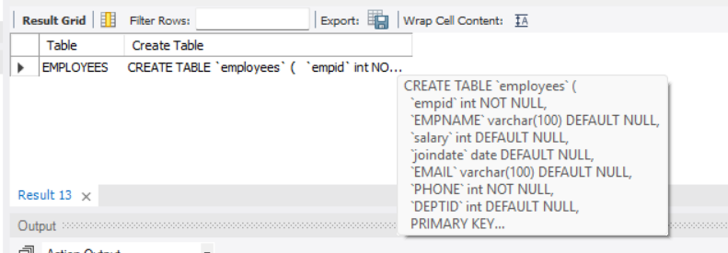
- Rename the column EmpName to EmployeeName.
ALTER TABLE EMPLOYEES
RENAME COLUMN EMPNAME TO EmployeeName;
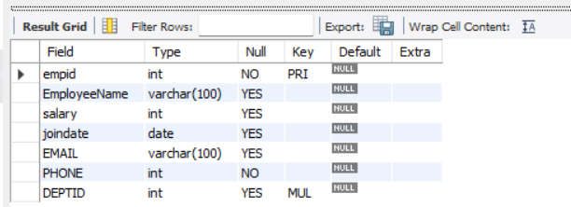
- Apply a CHECK constraint on the Age and Salary columns.
ALTER TABLE EMPLOYEES
ADD CONSTRAINT CHK_AGE CHECK (AGE >= 18);

ALTER TABLE EMPLOYEES
ADD CONSTRAINT CHK_SALARY CHECK (SALARY > 0);

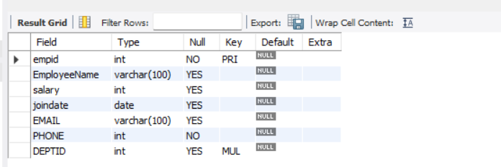
- Remove the Phone column from the Employees table.
ALTER TABLE EMPLOYEES DROP COLUMN PHONE
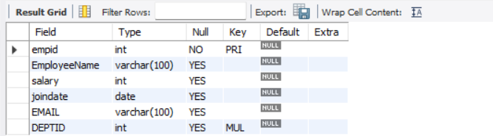
- Rename the table Employees to EmployeeDetails.
RENAME TABLE EMPLOYEES TO EMPLOYEESDETAILS
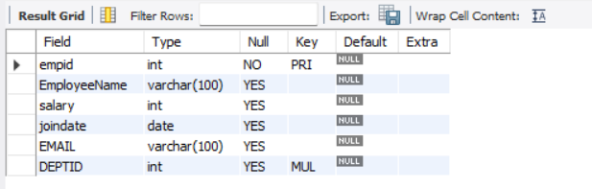
- Drop the CHECK constraints.
ALTER TABLE EMPLOYEES DROP CONSTRAINTS
ALTER TABLE EmployeeSDetails
DROP CHECK CHK_AGE;

ALTER TABLE EmployeeSDetails
DROP CHECK CHK_SALARY;
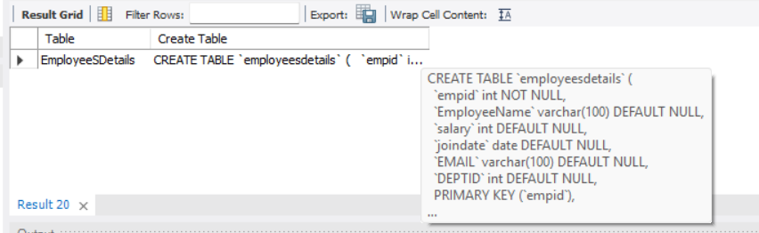
- Delete the Departments table permanently.
DROP TABLE DEPARTMENTS

ALTER TABLE employeesdetails
DROP FOREIGN KEY FK_DEPT;

DROP TABLE DEPARTMENTS;

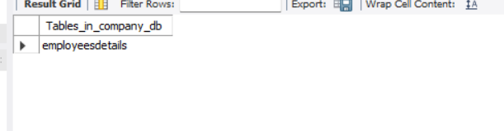
- Drop the database.
DROP DATABASE COMPANY_DB
